Project 1: Explore Weather Trends

The project intention is to explore and compare global and local weather trends. Follow the below steps.

## Step 1: Query and save needed data to CSV file

### The Database Schema

There are three tables in the database:

* city_list - This contains a list of cities and countries in the database. Look through them in order to find the city nearest to you.
* city_data - This contains the average temperatures for each city by year (ºC).
* global_data - This contains the average global temperatures by year (ºC).

### Process of querying and saving data

- Query all cities in Vietnam to know what is the nearest big city. Choose Hanoi as the locality.

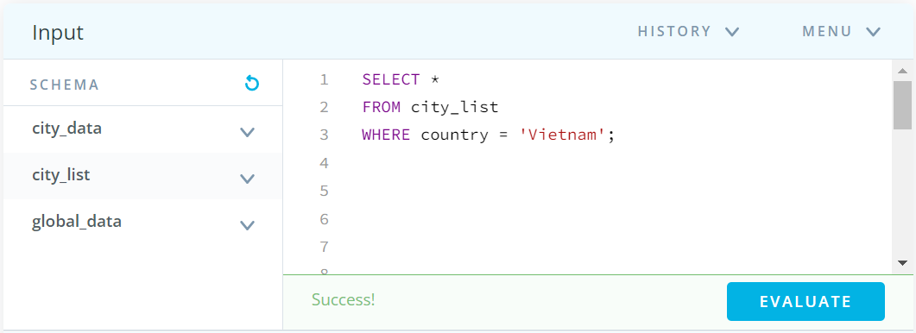

- Query all average temperature data in Hanoi over years.

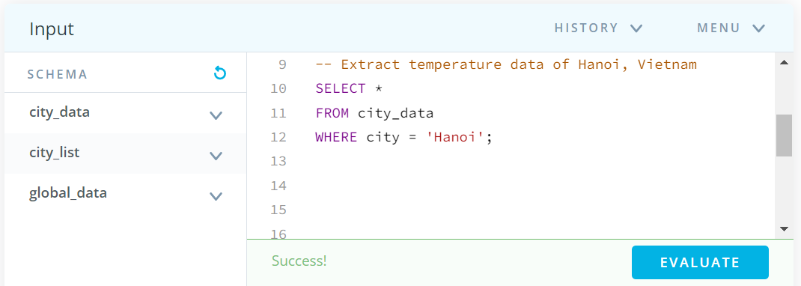- Query all global average temperature data. 

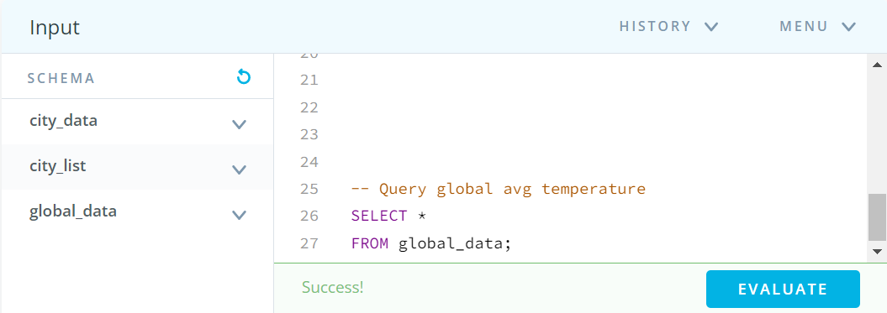

## Step 2: Calculate data

- Copy 2 above result tables into each sheet of the new file.

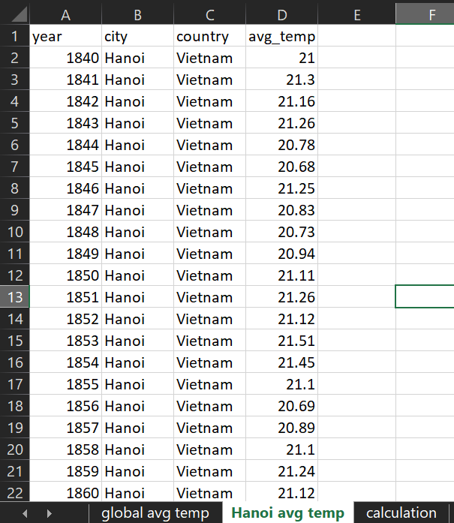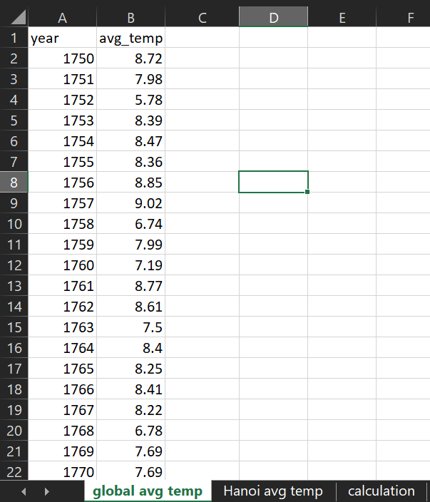

- Open new sheet in the same file named ‘calculation’ to retrieve and calculate the global and local 7-year moving average temperature.

- Use VLOOKUP function to retrieve global and local average temperature data for corresponding year. The B column is global average temperature data. The D column is local average temperature data.

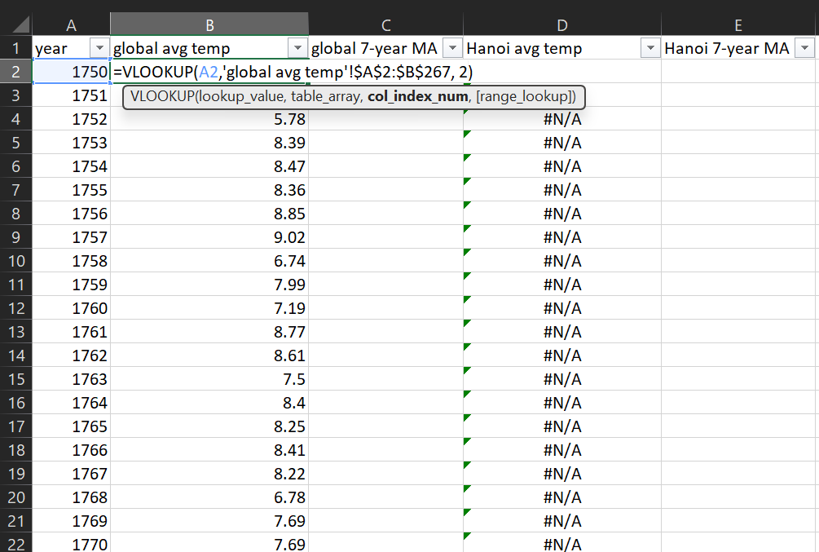

- The data just includes the local average temperature from 1840, so I decide to compare 7-year average temperature of global and local from 1840 to 2015.

- After that, use AVERAGE function to calculate 7-year moving average temperature for global and local. The C column is global 7-year average temperature data. The E column is local 7-year average temperature data.

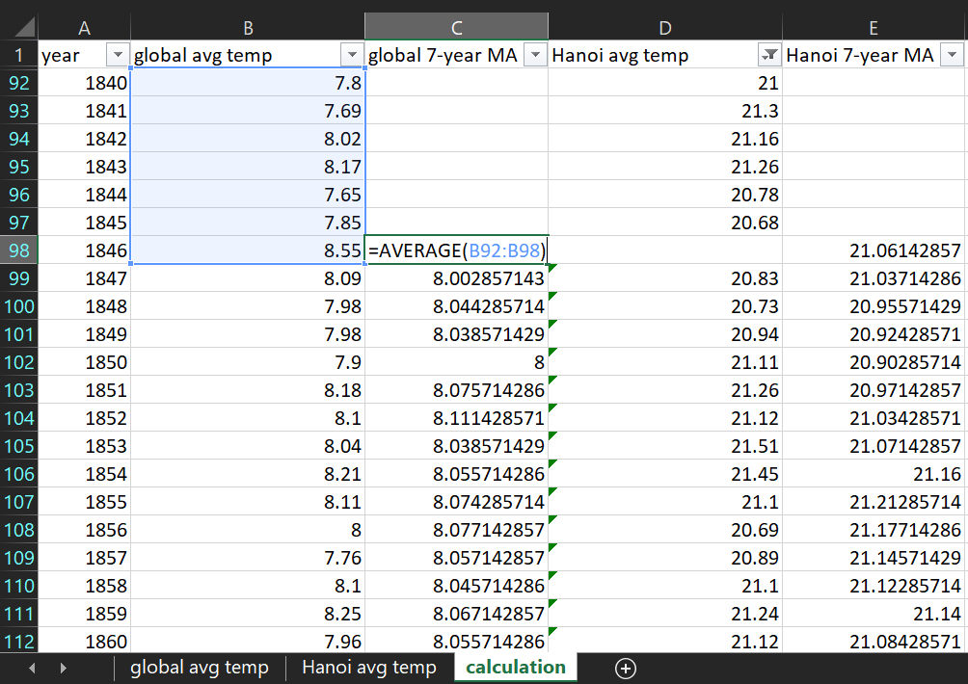

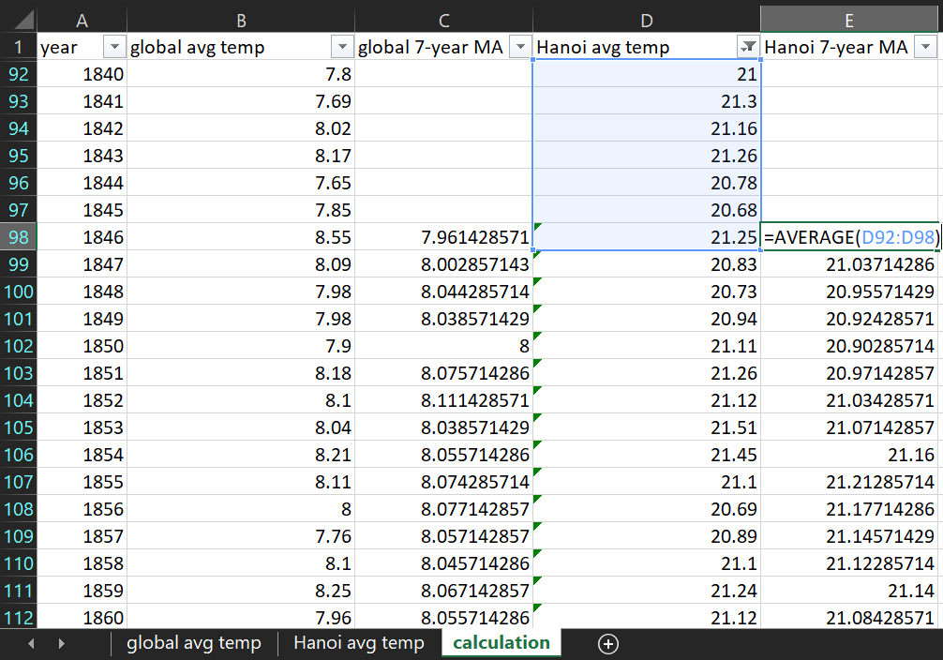

## Step 3: Visualize data

Create a line chart to show the different global and local average temperature over years (from 1840 to 2015). Use moving averages to smooth out data and make it ealier to observe long term weather trends. And apply combine two line chart to compare global and local easily. The final file is here. 

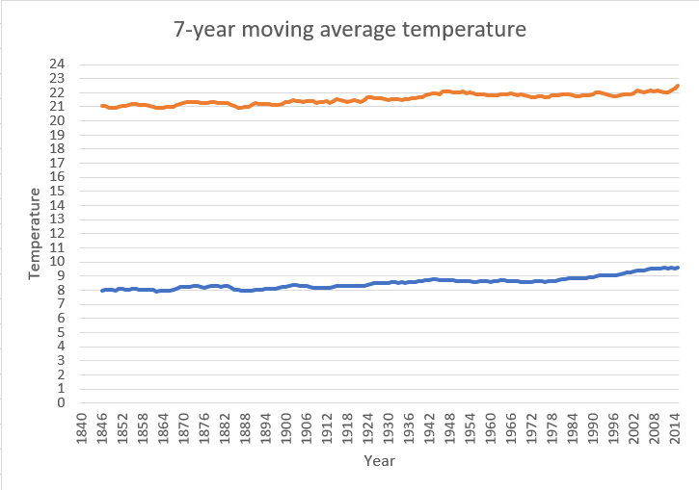

## Step 4: Make data observations

- Hanoi, my city is consistently hotter on average compared to the global average over time. The difference is around 13 C degree.

- Globally and locally, both have an increasing trend in average temperatures.

- The world is getting hotter, increased more than 2 C degree since 1840.

- Entering the 21st century, the average temperature increased very high. The increase in temperature from 2000 to 2015 is comparable to the increase from the mid-19th century to the end of the 20th century. 